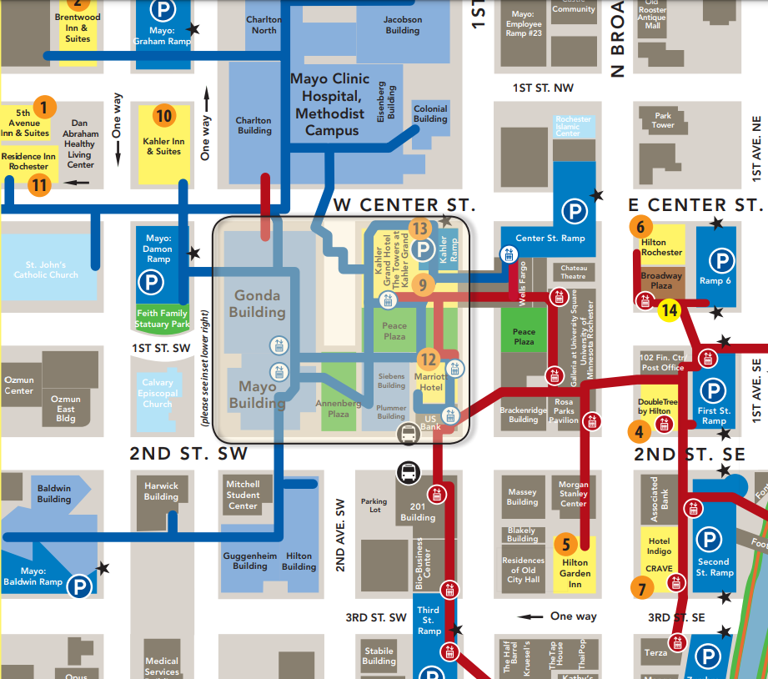
Map Key:

= Hotels blocked for Training
- Marriott Hotel
(101 1st Avenue SW • 507-280-6000)
- Residence Inn Rochester
(441 W Center Street • 507-292-1400)

= Location of Tobacco Treatment Specialist Training
- Siebens Building
(Siebens Building, Floor 4, Room 5)

= Route to take to Siebens
Building/Training
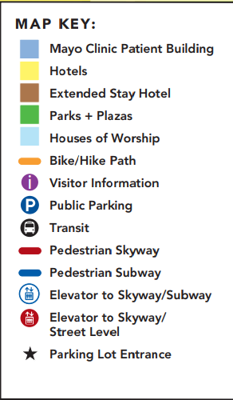

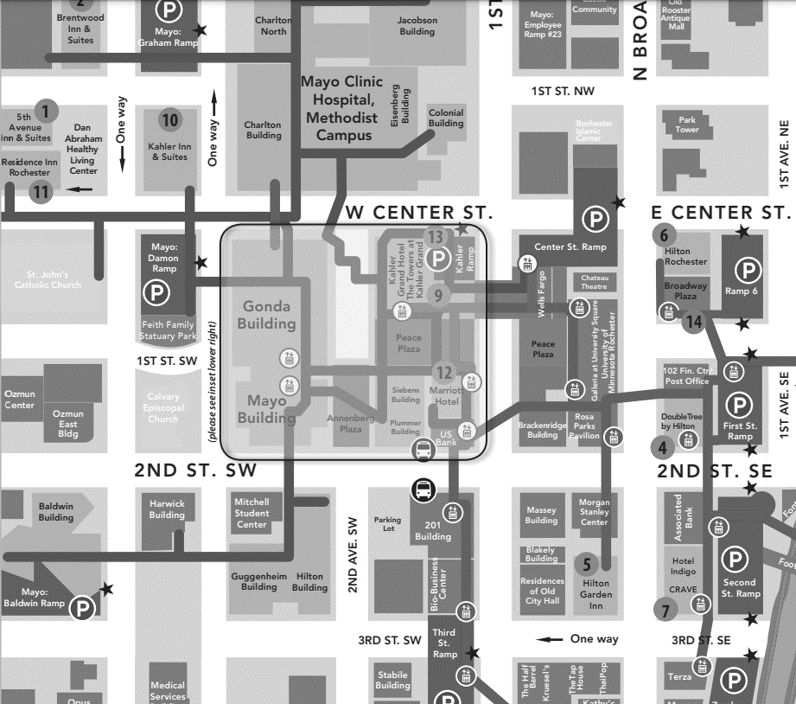
Map Key:

= Hotels blocked for Training
- Marriott Hotel
(101 1st Avenue SW • 507-280-6000)
- Residence Inn Rochester
(441 W Center Street • 507-292-1400)

= Location of Tobacco Treatment Specialist Training
- Siebens Building
(Siebens Building, Floor 4, Room 5)

= Route to take to Siebens
Building/Training

